21st-century skills
- Critical Thinking
The Cambridge Assessment definition of Critical Thinking
Critical Thinking is the analytical thinking which underlies all rational discourse and enquiry. It is characterised by a meticulous and rigorous approach. As an academic discipline, it is unique in that it explicitly focuses on the processes involved in being rational. These processes include:
- analysing arguments
- judging the relevance and significance of information
- evaluating claims, inferences, arguments and explanations
- constructing clear and coherent arguments
- forming well-reasoned judgements and decisions.
Being rational also requires an open-minded yet critical approach to one’s own thinking as well as that of others.
Rationale/explication of the Cambridge Assessment definition of Critical Thinking.
- The definition strongly equates Critical Thinking with rationality. Thus, in one sense, Critical Thinking (CT), as an activity, is ubiquitous: all rational discourse and enquiry involves the activity and application of CT. Both formal (subject domains across the science-humanities divide) and informal (everyday) rational discourse and enquiry rely upon analytical and reasoned thought.
- The definition highlights that one of the main features of CT is that it is analytical. Many of the processes of CT rest upon the ability to be analytical; to be able to dissect arguments and information.
- Good Critical Thinking is exemplified when the thinking is rigorous and meticulous. That is to say that CT is not passive, automatic, spontaneous or reactive in manner, but is active, careful and thorough.
- Whilst CT, as a form of thinking, can be acquired and exercised through incidental exposure in one’s general educational experience, the reference to CT as an academic discipline acknowledges that this is a set of skills which can be explicitly and purposefully learnt and taught [11]. CT comprises a number of processes involved in being rational. These processes are often implicit, hidden or tacit. Studying CT makes these processes unconcealed and explicit. Therefore, whilst a person who has had an absence of any overt CT teaching might still be equipped with a range of CT skills, explicit teaching of CT can introduce awareness or increase proficiency in the processes involved in being rational. The value of the discipline is that it can be applied in all contexts in which reasoning occurs or should occur.
- CT emphasises processes - hence the inclusion in the definition of five of the most significant of the many processes of rationality, which encompass the skills and sub-skills outlined in the taxonomy.
- Open-mindedness is an important aspect of CT. Being able to set aside one’s own views is a prerequisite for a thorough examination of another’s argument, allowing apprehension of other frames of reference. Furthermore, open-mindedness allows a person to acknowledge that their own views may be unsupported or even wrong. Critical Thinking involves a fair assessment of evidence, rather than seeking to support or confirm one’s own views.
- The definition indicates that CT is a set of skills which one applies not only to other people’s reasoning, but also to one’s own. Being rational requires analysis, evaluation and elucidation of one’s own thinking, with the aim of greater internal coherence in one’s own reasoning.
- [11] It is worth making a distinction between learnability and coachability. Learnability is where a skill or set of skills can be acquired, learnt and enhanced so the student experiences a meaningful and lasting advancement in respect of these skills. Coachability is whereby a skill or set of skills may experience apparently a short term and superficial gain, usually after some short-term intensive course. It is likely that Critical Thinking skills, because of their complexity, are not prone to coachability.
[Critical Thinking – a definition and taxonomy for Cambridge Assessment: supporting validity arguments about Critical Thinking assessments administered by Cambridge Assessment. Paper presented at 34th International Association of Educational Assessment Annual Conference, 9th September 2008, Cambridge. Beth Black]

Appendix F: Cambridge taxonomy with expansion (Black, 2008)
Categories | Subcategories | Expansion
1 Analysis | - Recognising and using the basic terminology of reasoning | E.g. argument, reasons, conclusions, analogy, inference, assumptions, flaws. This skill underpins most critical thinking skills.
1 Analysis | - Recognising arguments and explanations | Recognising arguments is a fundamental sub-skill in Critical Thinking. (An argument is defined as one or more reasons offered in support of a conclusion). Being able to distinguish between argument and non-argument, as well as between argument and explanation.
1 Analysis | - Recognising different types of reasoning | Recognising that arguments use different types of reasons, e.g. common knowledge, statistics, conditional statements, scientific data, ethical principles, etc. More advanced recognition will include recognising different forms of argument, e.g. deductive proof, hypothetical reasoning, and reductio ad absurdum.
1 Analysis | - Dissecting an argument | Extracting and separating the relevant material from the less relevant (e.g. rhetoric, background). Identifying the key claims which might form parts of the argument.
1 Analysis | - Categorising the component parts of an argument and identifying its structure. | Recognising the parts of an argument and the function they play. E.g. evidence, examples, reasons  While “dissecting an argument” and “categorizing component parts” often co-occur and work together iteratively, they are separate subskills.
1 Analysis | - Identifying unstated assumption | Looking for things (e.g. facts, beliefs, principles) which are essential to the argument but have not been explicitly presented.
1 Analysis | - Clarifying meaning | Detecting, avoiding and removing ambiguity for the purposes of reasoning soundly or judging the soundness of reasoning. Removing confusion over the meaning of words, phrases or expression of ideas that might alter the thrust or efficacy of the argument.
2 Evaluation | - Judging relevance | The process is more than simply judging relevant versus irrelevant. It entails judging the degree of relevance of a claim or piece of evidence to a particular interpretation or conclusion.
2 Evaluation | - Judging sufficiency | Determining whether there is enough evidence to support a conclusion. Recognising the difference between necessary and sufficient conditions
2 Evaluation | - Judging significance | This entails judging the degree of importance of evidence in relation to conclusions and arguments.
2 Evaluation | - Assessing credibility | Assessing the credibility of sources of evidence in relation to such criteria as expertise, corroboration of conflict, reputation, bias, factors that might interfere with accuracy of observation, judgement or reporting.
2 Evaluation | - Assessing plausibility | In relation to claims, assessing the likelihood that a claim could be true, i.e “Is this the sort of thing which is likely to happen?”
2 Evaluation | - Assessing analogy | Judging whether two things being compared are sufficiently alike for the comparison to be useful (i.e. in clarifying and strengthening an argument).
2 Evaluation | - Detecting errors in reasoning | Detecting errors in reasoning includes flaws in arguments, some common fallacies, incorrect inferences/ deductions from information contained in a variety of sources (e.g. verbal, numerical, pictorial, graphical), as well as unfair manoeuvres such as irrelevant appeals e.g. to popularity.
2 Evaluation | - Assessing the soundness of reasoning within an argument | Making an overall judgement as to how well the conclusion has been supported or justified by the argument as a whole. This will include considering the truth or plausibility of any of the individual claims or reasons, as well as the validity of reasoning (the degree to which the reasons support the conclusion.) The manner of assessment should be appropriate to the type of argument being assessed, e.g. deductive proof, causal reasoning, attempting to prove beyond reasonable doubt, attempting to establish likelihood based on balance of evidence.
2 Evaluation | - Considering the impact of further evidence upon an argument | Judging the extent to which further evidence strengthens or weakens an argument. It may challenge support, complement or conflict with evidence, reasons or unstated assumptions.
3 Inference | Considering the implications of claims, points of view, principles, hypotheses and suppositions | This requires looking at the wider implications of the components of the argument, including its overall conclusion.  This will include checking for consistency and corroboration between the claims within an argument.  Principles may be ethical principles.
3 Inference | Drawing appropriate conclusions | This involves ensuring the conclusion one draws is justified
4 Synthesis/  construction | Selecting material relevant to an argument | Gathering and collating appropriate and sufficient evidence.
4 Synthesis/  construction | Constructing a coherent and relevant (counter) argument | Using one’s knowledge of argument structure to construct one’s own argument.
4 Synthesis/  construction | Taking arguments further | Extending an existing argument. Constructing new lines of reasoning which advance the argument.
4 Synthesis/  construction | Forming well-reasoned judgements⁵ | Arriving at carefully considered and more accurate judgements in situations where there is insufficient evidence to allow certainty. (This involves applying all the relevant critical thinking skills)
4 Synthesis/  construction | Responding to dilemmas | This skill is applied in a situation where some action has to be taken in response to a problem, but any action  taken will have undesirable consequences. It involves recognition of the consequences of competing courses of action, and an attempt to judge between them.
4 Synthesis/  construction | Making and justifying rational decisions | Deciding upon the best course of action once a conclusion has been drawn having applied the relevant critical thinking skills
5 Self-reflection & Self-correction | Questioning one’s own pre-conceptions | Gaining awareness of, examining and evaluating one’s own pre-conceptions and being prepared to set them aside.
5 Self-reflection & Self-correction | Careful and persistent evaluation of one’s own reasoning | Applying all of the above to oneself, with the aim of greater accuracy in one’s own reasoning.

5 Judgement is wider than conclusion – it can mean a response, a decision.
Critical Thinking – a definition and taxonomy for Cambridge Assessment Beth Black Research Division, Joe Chislett, Anne Thomson, Geoff Thwaites and Jacquie Thwaites
This is a single article from Research Matters: A Cambridge Assessment publication. http://www.cambridgeassessment.org.uk/research-matters/ ©UCLES2008

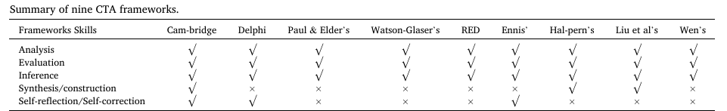
The debates on the definitions and components of CTA provide a research gap for this study. Two elements - synthesis/construction and self-reflection/self-correction - are included in only three out of nine frameworks. Can they be identified in the framework of CTAinEFL? This research sought to investigate the existence of these two skills in the context of EFL learning. After a comparison of the frameworks listed above, the Cambridge framework was chosen as the baseline framework for construct exploration because it is comprehensive, process-oriented (Black, 2008, 2012), and operationalisable. The first advantage of the Cambridge framework is that it is the most inclusive since it is the only one that comprises all five CT skills, as indicated in Table 1. The second advantage of the framework is that the skills in the framework are listed in the order of a natural thinking process (Black, 2008, 2012). The process-oriented display of the skills shows how the skills happen naturally to critical thinkers and helps readers to understand the whole rational thinking process. The third advantage of the Cambridge CTA framework is the expansion of subskills. The skills are classified into subskills, and the subskills are further explained by the expansion/indicators, with which users can understand what each skill consists of and stand for (see Appendix F). The research aim of the study was to explore the construct of CTAinEFL and clarify it with clear, understandable and operationalisable items. Therefore, the CTA Cambridge Framework provided an ideal basis for construct mapping in this research.

Appendix E: The third version of the CTA framework
skills | subskills | indicators
I Recogni-tion &  Analysis | 1. Recognizing argument components  2. Recognizing logical structures | 1.1 recognizing subclaims in English passages  1.2 recognizing supporting evidence in English arguments  1.3 recognizing ways of making arguments  2.1 recognizing common references in English passages  2.2 recognizing cohesion and coherence in English passages  2.3 recognizing time order in English narratives  2.4 recognizing spatial relationships in English passages  2.5 recognizing causal relationships in English passages  2.6 recognizing conclusions and supporting evidence/arguments
 | 3. Recognizing structures of articles | 3.1 separating English articles into several paragraphs  3.2 understanding different structures for different genres of discourse  3.3 understanding that a claim is always in the first or last paragraph in an English article
 | 4. Recognizing writing purposes | 4.1 understanding the general writing purposes of English narratives and expositions
 |  | 4.2 understanding the general writing purposes of English argumentation
 |  | 4.3 understanding the writing purposes of English advertisements
 |  | 4.4 understanding the writing purposes of English news reports
 | 5. Comparing  Chinese and English | 5.1 understanding differences in grammatical rules between English and Chinese  5.2 comparing Chinese traditional festivals with English ones  5.3 comparing Chinese customs with English ones
5.4 understanding western humors
5.5 understanding the meaning of English proverbs
5.6 understanding the meaning of idiomatic expressions
II.  Evaluation | 6. Judging credibility  7. Judging plausibility | 6.1 judging the credibility of articles by checking whether details contradict facts  6.2 judging the currency of materials  6.3 judging the authority of materials based on authors & publishers  7.1 judging the plausibility of claims by logic in the article  7.2 discussing with classmates the plausibility of answers to each item  7.3 discussing with teachers the plausibility of answers to each item
III | 8. Inferring the implied meaning of words, phrases | 8.1 guessing the meaning of new words based on context  8.2 inferring the meaning of phrases based on context  8.3 inferring the meaning of sentences based on context
Inference | and sentences
 | 9. Inferring the implied meaning of passages | 9.1 making inferences based on clues within paragraphs  9.2 making inferences based on clues across paragraphs  9.3 making inferences from English discourses
 |  | 9.4 inferring writing intentions from English passages
 |  | 9.5 inferring writing attitudes, such as neutral, positive and negative
 | 10. Predicting main ideas | 10.1 predicting main ideas based on passage titles  10.2 predicting main ideas based on the first sentences in passages  10.3 predicting the forthcoming content based on the existing passages
 | 11. Summarizing main ideas | 11.1 summarizing the main idea of each paragraph in English  11.2 choosing the suitable title for each paragraph
 |  | 11.3 summarizing main ideas of English narratives and expositions
 |  | 11.4 summarizing claims based on sub-claims in English passages
 |  | 11.5 summarizing main ideas of several paragraphs
IV | 12. Synthesizing main ideas | 12.1 presenting passage structures with mind maps  12.2 sorting out the main points of English passages by using time clues
Synthesis & construction | 13. Constructing new concepts | 12.3 presenting main points of English articles by space clues  13.1 expressing opinions on general topics in English  13.2 making arguments and counter-arguments in English
 |  | 13.3 making arguments with examples in English
 |  | 13.4 making arguments with data in English
 |  | 13.5 refuting opponents’ arguments
 |  | 13.6 adapting original texts into other genres of writing
V. Self-reflection/ correction | 14. Self-reflection | 14.1 reflecting on one’s own thinking on wrong answers to English items  14.2 reflecting on one’s own thinking before discussing items with others  14.3 reflecting on one’s own thinking in discussing items with others
 | 15. Self-correction | 15.1 reflecting on and correcting one’s own thinking by discussing items with others
 |  | 15.2 reflecting on and insisting on one’s own thinking by discussing items with others

Mapping the taxonomy of critical thinking ability in EFL
Xuelian Li a a , Jianda Liu b , * School of English education, Guangdong University of Foreign Studies, China b Center for Linguistics and Applied Linguistics, Guangdong University of Foreign Studies, China

Appendix F: Mapped Cambridge taxonomy with expansion (Black, 2008)
Categories | Subcategories | Expansion
1 Analysis | - Recognising and using the basic terminology of reasoning (Remembering + Applying) | E.g. argument, reasons, conclusions, analogy, inference, assumptions, flaws. This skill underpins most critical thinking skills.
1 Analysis | - Recognising arguments and explanations (Remembering + Understanding) | Recognising argument is a fundamental sub-skill in Critical Thinking. (An argument is defined as one or more reasons offered in support of a conclusion). Being able to distinguish between argument and non-argument as well as between argument and explanation.
1 Analysis | - Recognising different types of reasoning (Remembering+Understanding) | Recognising that arguments use different types of reasons, e.g. common knowledge, statistics, conditional statements, scientific data, ethical principles, etc. More advanced recognition will include recognizing different forms of argument, e.g. deductive proof, hypothetical reasoning, reductio ad absurdum.
1 Analysis | - Dissecting an argument (Analysing) | Extracting and separating the relevant material from the less relevant (e.g. rhetoric, background). Identifying the key claims which might form parts of the argument.
1 Analysis | - Categorising the component parts of an argument and identifying its structure. (Understanding+Remembering+Analysing) | Recognising the parts of an argument and the function they play. E.g. evidence, examples, reasons  While “dissecting an argument” and “categorizing component parts” often co-occur and work together iteratively, they are separate subskills.
1 Analysis | - Identifying unstated assumption (Remembering+Understanding) | Looking for things (e.g. facts, beliefs, principles) which are essential to the argument but have not been explicitly presented.
1 Analysis | - Clarifying meaning (Understanding+Analysing) | Detecting, avoiding and removing ambiguity for the purposes of reasoning soundly or judging the soundness of reasoning. Removing confusion over the meaning of words, phrases or expression of ideas that might alter the thrust or efficacy of the argument.
2 Evaluation | - Judging relevance (Evaluating) | The process is more than simply judging relevant versus irrelevant. It entails judging the degree of relevance of a claim or piece of evidence to a particular interpretation or conclusion.
2 Evaluation | - Judging sufficiency (Evaluating) | Determining whether there is enough evidence to support a conclusion. Recognising the difference between necessary and sufficient conditions
2 Evaluation | - Judging significance (Evaluating) | This entails judging the degree of importance of evidence in relation to conclusions and arguments.
2 Evaluation | - Assessing credibility (Evaluating) | Assessing the credibility of sources of evidence in relation to such criteria as expertise, corroboration of conflict, reputation, bias, factors that might interfere with accuracy of observation, judgement or reporting.
2 Evaluation | - Assessing plausibility (Evaluating) | In relation to claims, assessing the likelihood that a claim could be true, i.e. “Is this the sort of thing which is likely to happen?”
2 Evaluation | - Assessing analogy (Evaluating) | Judging whether two things being compared are sufficiently alike for the comparison to be useful (i.e. in clarifying and strengthening an argument).
2 Evaluation | - Detecting errors in reasoning (Remembering+Understanding+Evaluating or Evaluating) | Detecting errors in reasoning includes flaws in arguments, some common fallacies, incorrect inferences/ deductions from information contained in a variety of sources (e.g. verbal, numerical, pictorial, graphical), as well as unfair manoeuvres such as irrelevant appeals e.g. to popularity.
2 Evaluation | - Assessing the soundness of reasoning within an argument (Evaluating) | Making an overall judgement as to how well the conclusion has been supported or justified by the argument as a whole. This will include considering the truth or plausibility of any of the individual claims or reasons, as well as the validity of reasoning (the degree to which the reasons support the conclusion.) The manner of assessment should be appropriate to the type of argument being assessed, e.g. deductive proof, causal reasoning, attempting to prove beyond reasonable doubt, attempting to establish likelihood based on balance of evidence.
2 Evaluation | - Considering the impact of further evidence upon an argument (Evaluating) | Judging the extent to which further evidence strengthens or weakens an argument. It may challenge support, complement or conflict with evidence, reasons or unstated assumptions.
3 Inference | - Considering the implications of claims, points of view, principles, hypotheses and suppositions (Analysing + Evaluating) | This requires looking at the wider implications of the components of the argument, including its overall conclusion.  This will include checking for consistency and corroboration between the claims within an argument.  Principles may be ethical principles.
3 Inference | - Drawing appropriate conclusions (Evaluating) | This involves ensuring the conclusion one draws is justified
4 Synthesis/  construction | - Selecting material relevant to an argument (Analysing) | Gathering and collating appropriate and sufficient evidence.
4 Synthesis/  construction | - Constructing a coherent & relevant argument or counterargument. (Creating) | Using one’s knowledge of argument structure to construct one’s own argument.
4 Synthesis/  construction | - Taking arguments further (Creating) | Extending an existing argument. Constructing new lines of reasoning which advance the argument.
4 Synthesis/  construction | - Forming well-reasoned judgements⁵(Evaluating) | Arriving at carefully considered and more accurate judgements in situations where there is insufficient evidence to allow certainty. (This involves applying all the relevant critical thinking skills)
4 Synthesis/  construction | - Responding to dilemmas (Remembering + Evaluating) | This skill is applied in a situation where some action has to be taken in response to a problem, but any action  taken will have undesirable consequences. It involves recognition of the consequences of competing courses of action, and an attempt to judge between them.
4 Synthesis/  construction | - Making and justifying rational decisions (Creating + Evaluating) | Deciding upon the best course of action once a conclusion has been drawn having applied the relevant critical thinking skills
5 Self-reflection & Self-correction | - Questioning one’s own pre-conceptions (Analysing + Evaluating) | Gaining awareness of, examining and evaluating one’s own pre-conceptions and being prepared to set them aside.
5 Self-reflection & Self-correction | - Careful and persistent evaluation of one’s own reasoning (Applying + Evaluating) | Applying all of the above to oneself, with the aim of greater accuracy in one’s own reasoning.

Examples
- Recognising structure: If the teacher is telling which type of questions and strategies to solve them in STEM (Categorising the component parts of an argument and identifying its structure - Analysis)
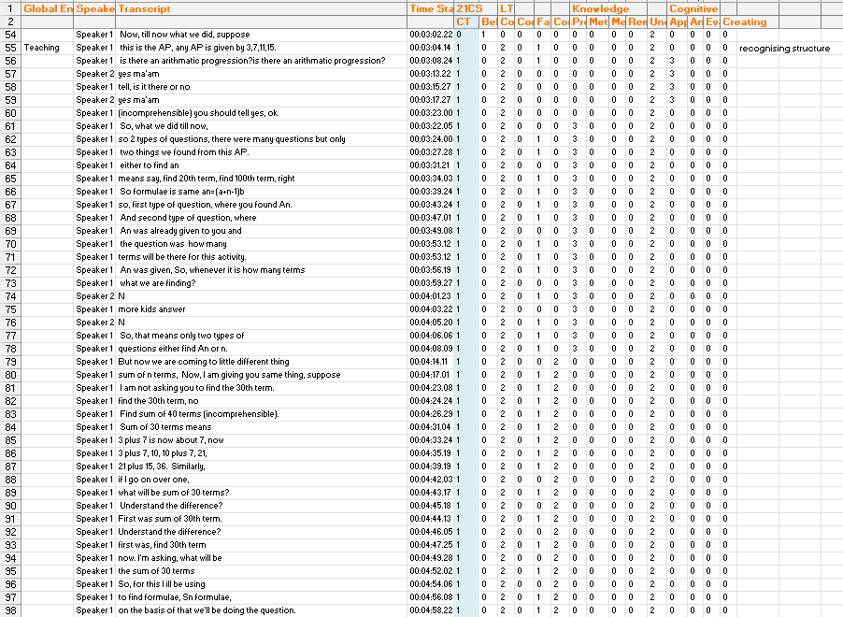
20220729_093414ah_10a_math1

- Comparing (the teacher asks which is correct between option a and b)
Analysis [Categorising the component parts of an argument and identifying its structure. (Understanding+Remembering+Analysing)]

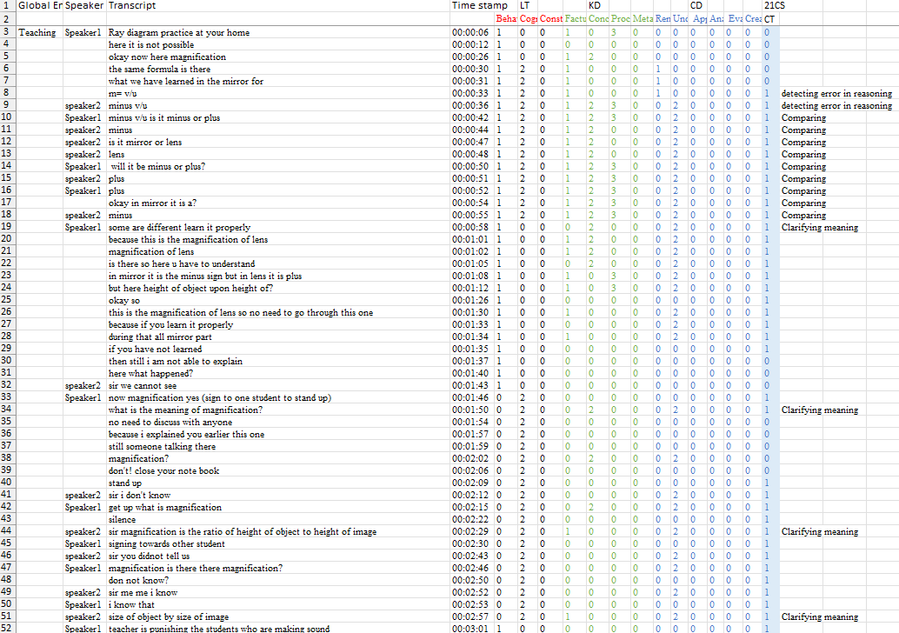
20220721_124928svs_10a_sci

- Clarifying meaning (If teacher is telling the meaning, importance and application in real life of a concept)-[ Analysis-Clarifying meaning (Understanding+Analysing)]
Note: Clarifying meaning is part of the “Analysing arguments” process of the CT model provided in The Cambridge Assessment definition of Critical Thinking. In our study, when the teacher clarifies the meaning (say Molarity) to students, we assume that students are learning not only the meaning of the concept Molarity but also are learning to clarify the meaning while looking at the definition of Molarity as an argument and how to clarify the meaning of this definition. This is somewhat passive in the sense that, in many of these conversations, mostly the teacher is clarifying the meaning by giving analogies, etc., but between the discussions, students also do that when prompted to do so. When students ask to clarify the meaning of a definition it is very apparent that CT is actively occurring but In cases where Teacher is telling the meaning of a definition it can be argued that students still learn CT passively At the end of the day, we are saying that while the teacher is doing “Analysing argument” (If the definition of molarity can be seen as an argument), students must be learning the skill of looking for the meaning of the definition of Molarity and hence learning the skill of CT. All we are saying is that by discussing the meaning of a definition, the teacher is essentially creating an opportunity for students to learn CT by making a habit of looking for the meaning of definitions (Clarifying meaning), and hence CT occurs. Hence, the scenarios where the teacher asks students to clarify the meaning of definitions of concepts, etc, and then tells them the meaning of concepts can be called as an indicator or evidence for the occurrence of CT.
Clarifying meaning is a key subskill of the Analysing arguments component in the Cambridge Critical Thinking framework. When a teacher unpacks a definition—such as molarity—through analogies, real-life examples, or guided questioning, students are not only learning the concept itself but also the process of treating a definition like an argument and extracting its precise meaning. Though largely teacher-driven, these explanations implicitly model analytical clarification, and when students themselves ask for or offer clarifications, they engage more actively in CT. In both cases, the act of discussing and making sense of definitions cultivates the habit of looking for meaning, making such scenarios reliable indicators that critical thinking is occurring.

- If the teacher is asking “why” or “because” type of question, i.e. basically if students are giving reasoning for doing a step or concept -[ Analysis-Clarifying meaning (Understanding+Analysing)]

20220810_122224_chem_tr
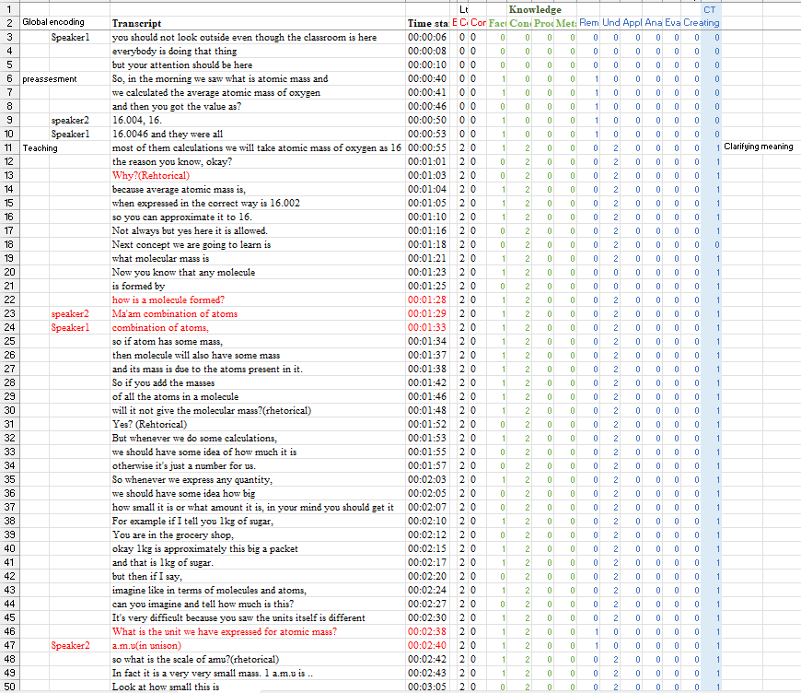

- Analogies to explain a concept -[ Analysis- Clarifying meaning (Understanding+Analysing)]

20220817_124545_11b_chem_tr
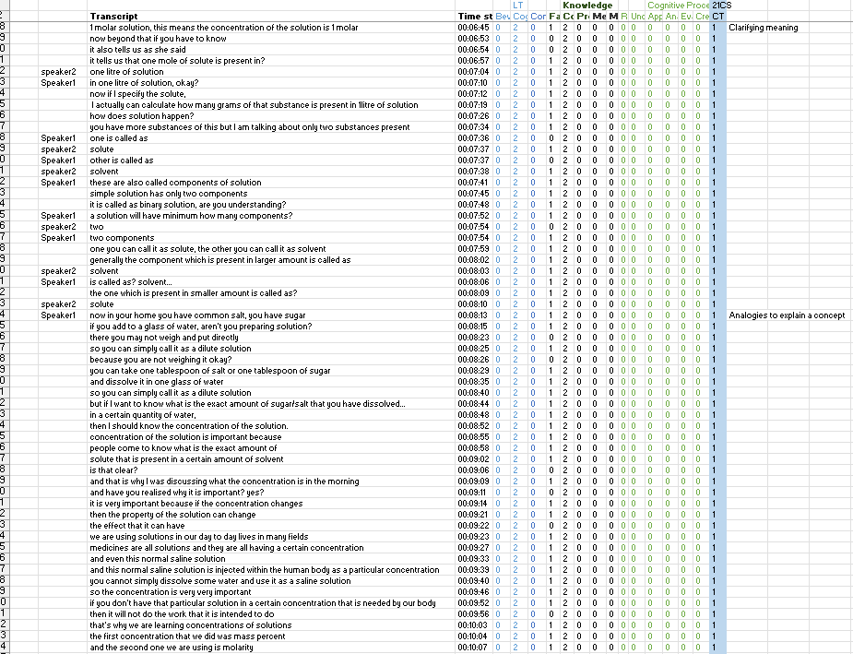

20220729_093414ah_10a_math1
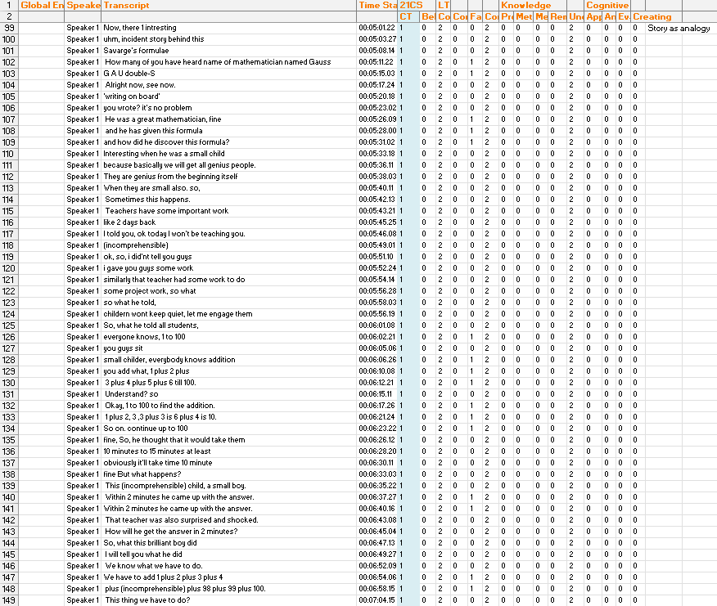

- If students are correcting other students or teachers (related to the subject)

20220721_124928svs_10a_sci

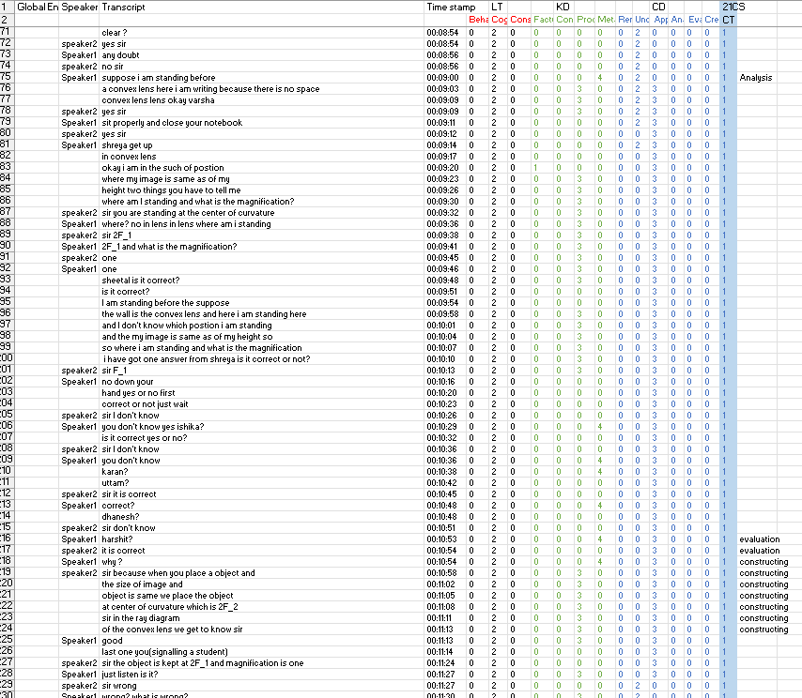
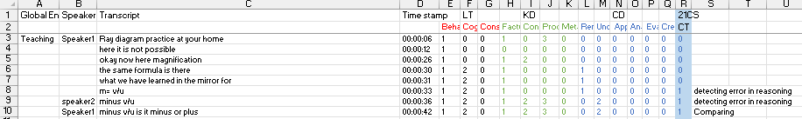

- Looking at the problem from multiple perspectives

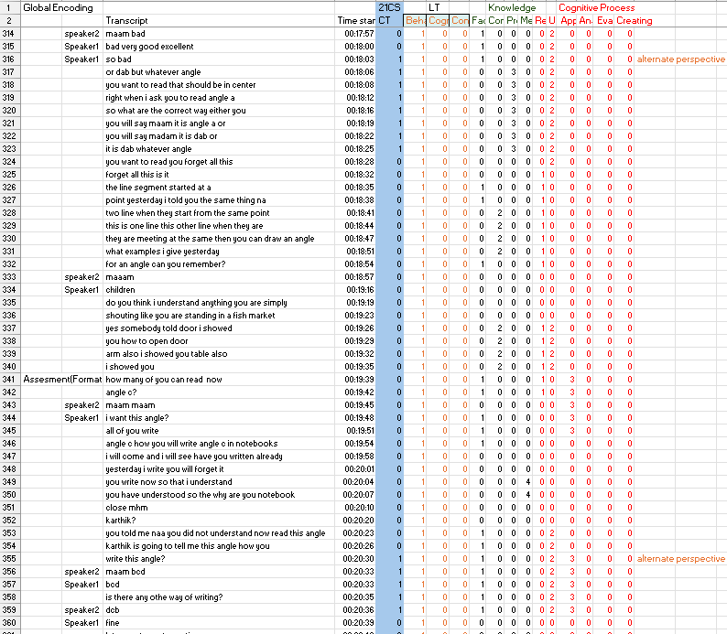
episode_4_2_08_2022_math_ah_6a

Rule | CT Process | Sub-skill | How It Aligns
1. Using analogies to explain a concept | Analysis | Clarifying meaning | You’re unpacking and removing ambiguity by recasting an idea in a familiar form.
2. Students correcting peers or teacher (on-topic) | Evaluation | Detecting errors in reasoning | Spotting and pointing out factual or logical mistakes is exactly the “detecting errors” sub-skill.
3. Looking at the problem from multiple perspectives | Inference | Considering implications | You’re exploring “what follows if we view it this way or that,” a core inference activity.

- If the teacher is giving a reflection from their side-
- Teacher self-reflection—her commenting on students’ struggles and explaining her own notation choices—is modelling the thinking process, but it isn’t itself a student’s Critical Thinking act as defined by the Cambridge framework. In the Cambridge taxonomy, Self-Reflection/Self-Correction refers to learners monitoring and adjusting their own reasoning. Here, the teacher is justifying her approach, so you would not code these lines as Self-Reflection/Self-Correction. If you wanted to code them at all, they’d more naturally sit under Analysis → Clarifying Method, since she’s unpacking how to set up the algebra to avoid sign-shifting errors (i.e. clarifying the procedure). But strictly speaking, teachers' explanations of their own thinking process are fringe to CT in this model—only students’ metacognitive moves count as genuine CT.
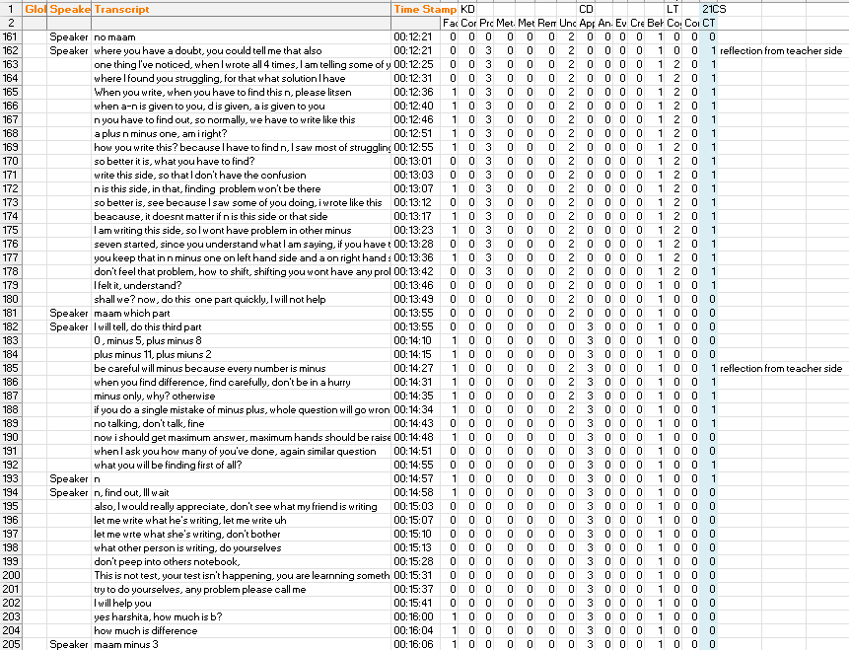

- Giving as many examples as possible of something or listing as many things as possible (creativity) is not considered CT. If somebody is making an argument and giving one example to clarify the meaning, it will be called an analogy and hence CT.
- In the assessment part, if the teacher is asking to define a concept and students are defining the concept in their own words, then this scenario is not CT. It is just “Understanding” (Bloom). In the 12th Bio class, when Madam explains concepts like “Central dogma” in her own words so that students can understand the meaning of that, it will be called CT because Madam is clarifying the meaning.
- If students are answering without giving reasons (single-word answer), or answering by recalling, then it is a simple recall and should not be classified as CT
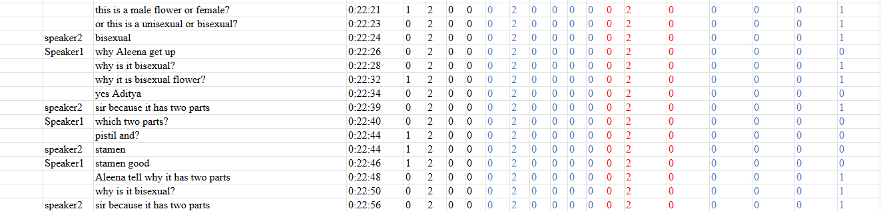
- If students are choosing between two options in response to a question prompted by a teacher having two or more options, then it is CT. In the below pic, the last column is CT. (6th_sci_6_08)
- Pure dictation of definitions or prompts to write terms does not count as Critical Thinking. The moments where the teacher or student moves beyond recall—by generalising, contrasting, or applying the concept—are where genuine CT appears.

Analysis Subskill | Science Example | Math Example
Recognising and using basic terminology of reasoning | Identifying terms like hypothesis, variable, control, data, e.g. distinguishing the “hypothesis” from the “result” in a lab report | Identifying terms like theorem, proof, axiom, lemma, e.g. distinguishing a “definition” from a “theorem” in a proof
Recognising arguments and explanations | Differentiating a claim supported by data (argument) from a descriptive account of a process (explanation); e.g. “This data shows…” vs “This happens because…” | Differentiating a formal proof (argument) from a worked example or illustration, e.g. recognising a deductive proof versus a motivational example
Recognising different types of reasoning | Noticing use of inductive vs. deductive vs. statistical reasoning, e.g. generalising a law from data vs deriving consequences from a theory | Recognising forms like direct proof, contradiction (reductio), or induction, e.g. identifying that a proof assumes the opposite of the conclusion (reductio)
Dissecting an argument | Pulling out key evidence and claims from irrelevant context in a research article, e.g. isolating measured data that support a conclusion | Breaking down a complex solution by isolating core logical steps from supplementary explanations
Categorising the component parts of an argument and its structure | Labelling claims, evidence, examples, and conclusions in a science write-up, e.g. marking which sentences are data vs hypothesis vs conclusion | Labelling premises (givens)[when the teacher recognises a, d(components) is given and we have to find n for an AP, this does not include when the teacher/student says a=20, d=2, etc. So when the teacher is telling students there are three types of question in AP], intermediate lemmas, and the final conclusion in a proof, e.g. identifying which statements are assumptions versus derived results
Identifying unstated assumptions | Noticing implicit conditions like “no friction” or “closed system” in an experiment, e.g. realising the result assumes constant temperature | Noticing hidden premises like “n≠0” when an expression divides by n, e.g. realising a solution assumes a variable is nonzero
Clarifying meaning | Disambiguating terms or statements, e.g. clarifying if “significant” means statistically significant or just notable, or defining what “concentration” refers to | Clarifying ambiguous notation or qualifiers, e.g. ensuring whether “*” means multiplication or convolution, or what “small n” quantitatively means
Evaluation Subskill | Science Example | Math Example
Judging relevance | Students determine which data directly addresses the scientific question and ignore extraneous details. For example, in an ecology experiment on soil nutrients, a student might focus on measurements of nitrogen and phosphorus (relevant variables) while disregarding the colour of the pot as unrelated. The student explicitly explains why certain observations are included and others excluded, demonstrating judgment of relevance | Students select only the numbers and conditions needed to solve the problem, ignoring irrelevant information. For example, in a math word problem about distance and time, a student uses the given speed and time values (relevant data) and ignores extraneous narrative details like the names of travellers. By focusing on the key quantities and discarding distractions, the student shows the ability to discern relevant information.
Judging sufficiency | Students evaluate whether the collected evidence or data is sufficient to support a conclusion. For example, in a chemistry experiment measuring reaction rate, a student might realise that having only one trial per condition is insufficient to be confident in the result, so they repeat the experiment to gather more data. They may say “we need more trials” or explicitly check that they have covered all necessary cases. This indicates the student is judging the sufficiency of their evidence | Students verify that they have enough examples or steps in a math problem. For example, when exploring a numerical pattern, a student might test several values (not just one) to ensure a conjecture holds, rather than accepting it from a single case. If the student notices an exception or recognises that additional cases should be checked, this shows awareness that more evidence is needed to justify the conclusion.
Judging significance | Students determine which factors or results are most important to the conclusion. For example, in a physics lab on pendulums, a student might note that the length of the string has a significant effect on oscillation period, whereas small differences in the pendulum’s colour have a negligible impact. The student justifies why certain variables strongly influence the outcome, demonstrating judgment of significance. | Students focus on the main terms and steps that are critical to solving a problem. For example, when simplifying an algebraic expression, a student might recognise that combining like terms is crucial to finding the correct result, while simply rearranging terms in the sum (commutativity) is of lesser significance to the final answer. By highlighting the core steps, the student shows understanding of which parts of the problem are most significant.
Assessing credibility | Students evaluate whether an information source or method is reliable. For example, a student might check if a scientific claim comes from a peer-reviewed journal or a reputable textbook instead of an unsourced website. In the lab, they prefer data from a calibrated instrument over a quick estimate. The student looks for verifiable facts and trusted references, demonstrating assessment of credibility | Students verify that a mathematical method or result is based on sound principles. For example, a student may recall that the Pythagorean theorem is well-established and trust a result derived from it, whereas an unfamiliar shortcut might be questioned. They may also ask if a peer’s solution follows known rules (e.g. algebraic laws) to check its validity. By confirming the method comes from proven mathematics, the student is assessing the credibility of the reasoning.
Assessing plausibility | Students judge whether an explanation or result is believable given existing knowledge. For example, if experimental data suggest a plant lost weight after adding fertiliser, a student might find this implausible (since we expect plants to gain mass) and question the procedure or data. The student might say, “That outcome seems unlikely because…,” showing they are evaluating the claim against what they know.” This seems not correct” type of statement. | Students consider whether a numerical answer is reasonable in context. For example, if a student’s calculation in a geometry problem yields a negative length for a shape’s side, they recognise this as impossible (lengths cannot be negative). The student then double-checks the work to resolve the contradiction, indicating assessment of the plausibility of the result.
Assessing analogy | Students evaluate how well an analogy or model applies and where it breaks down. For example, a student comparing an atom to a solar system might note that while electrons orbit a nucleus like planets orbit the sun, electrons do not follow fixed paths. The student explains which parts of the analogy are helpful and which parts do not match reality, demonstrating evaluation of the analogy’s usefulness. | Students scrutinise analogies between concepts. For example, if a student uses the balancing scale analogy to solve an equation, they might point out that it accurately represents keeping two sides equal (adding or removing weight on both sides) but does not capture operations like multiplication or division. By discussing how the analogy works and where it falls short, the student shows that they are assessing the analogy’s validity.
Detecting errors in reasoning | Students notice and correct mistakes in logic or procedure. For example, in a chemistry lab, if a student realises they added up volumes incorrectly when calculating concentration, they correct the arithmetic error before proceeding. Similarly, a student might point out a flaw in a classmate’s conclusion (e.g., confusing correlation with causation). By identifying and explaining such mistakes, the student demonstrates the ability to detect errors in reasoning (Wherever students correct the teacher or fellow students) | Students identify and fix errors in computation or logic. For example, while solving a long algebraic problem, a student may catch and correct an arithmetic slip. Or when reviewing a proof, a student might realise that a step was unjustified and adjust the reasoning. The student’s correction and explanation of the error show that they can detect and address faults in their mathematical reasoning. (Wherever students correct the teacher or fellow students)
Assessing the soundness of reasoning | Students evaluate whether an argument is logically valid and well supported by evidence. For example, a student might critique a scientific claim by checking each inference: “Given our data, this conclusion seems justified,” or “This claim isn’t supported by the evidence we have.” They examine the structure of the argument and the evidence behind each step, determining if the reasoning is sound | Students confirm that a mathematical solution is logically solid. For example, after solving an equation, a student might substitute the result back into the original equation to verify it satisfies the problem. Or in a proof, a student ensures each step follows from a known theorem. By verifying each part of the reasoning and its justifications, the student demonstrates assessing the soundness of the mathematical argument.(7c math class where checking happened)
Inference Subskill | Science Example | Math Example
1. Considering the implications of claims, points of view, principles, hypotheses and suppositions | After reading a hypothesis that “alloys with higher iron content corrode faster,” students discuss what this implies for material choice in bridge construction and predict downstream environmental impacts of rust runoff. [If acceleration is increasing, velocity will increase, and it will be harder to stop the vehicle] | Given the principle “if the sum of digits of a number is divisible by 3, the number is divisible by 3,” students infer which numbers up to 100 will be multiples of 3 and discuss how this rule affects divisibility tests in larger bases. (Needs a better example in math)
2. Drawing appropriate conclusions | From a series of titration results showing volume plateaus, students conclude that the reaction endpoint has been reached and identify the equivalence point with confidence. [If acceleration is increasing and force is increasing in the same proportion, they are proportional to each other.] | After examining the pattern of prime gaps (differences between consecutive primes) for the first 50 primes, students conclude that gaps tend to increase on average and articulate that primes become sparser as numbers grow.
Synthesis/Construction Subskill | Science Example | Math Example
1. Selecting material relevant to an argument | When debating acid rain causes, students pick only data on pH measurements and sulphur dioxide levels—not temperature or humidity readings—to support their claims. | In arguing that a sequence converges, students choose only the terms and limit definition applicable to convergence, discarding irrelevant pattern observations (e.g., occasional spikes). (Needs a better example in math)
2. Constructing a coherent and relevant argument or counter-argument | Students build a structured argument that “increased CO₂ leads to ocean acidification,” citing chemical equations, pH data trends, and countering the view that temperature is the sole driver. | Students write a proof that the sum of two even numbers is even: they start with definitions (even = 2k), show 2k₁ + 2k₂ = 2(k₁+k₂), then conclude the result follows logically.
3. Taking arguments further | After demonstrating that enzyme activity peaks at a certain temperature, students propose and justify further tests under different pH conditions to extend their findings. | Having proven a formula for arithmetic series, students explore its implications by deriving a related formula for the sum of an arithmetic progression with negative step sizes.
4. Forming well-reasoned judgements | Given conflicting studies on a drug’s efficacy, students weigh sample sizes, methodologies, and statistical significance to judge which conclusion is most reliable. | Faced with multiple methods to solve a system of equations (substitution, elimination, matrix), students compare efficiency, error potential, and choose the best method for large systems.
5. Responding to dilemmas | Presented with limited resources in a simulated conservation scenario, students prioritise endangered species protection vs. ecosystem services and justify their decision. | In a problem where two solution methods yield slightly different numerical approximations, students discuss the trade-offs (speed vs. accuracy) and decide which approach to adopt.
6. Making and justifying rational decisions | Students decide whether to increase the sample size or refine the measurement technique to reduce experimental error, explaining their choice based on cost-benefit analysis. | When rounding results in statistical calculations, students choose between rounding at intermediate steps or at the end, justifying which preserves most accuracy for their dataset.
Subskill | Science Example | Math Example
1. Questioning one’s own pre-conceptions | After assuming that heavier objects fall faster, students revisit Galileo’s experiments, question that belief, and research actual data showing constant acceleration in a vacuum. | Believing that all quadratic equations have real solutions, students test x² + 4 = 0, notice no real roots, and then question and revise their assumption about discriminants.
2. Careful and persistent evaluation of one’s own reasoning | During data analysis, a student keeps re-checking their calibration curve derivation step by step until the slope makes scientific sense, even after initial, correct-looking results. | While proving a theorem by induction, a student repeatedly verifies the base case, inductive step, and boundary conditions, persisting until any gap in logic is fully closed.

Below are sets of observable indicators you can use to detect each of the five CT processes (Analysis, Evaluation, Inference, Synthesis/Construction, Self-Reflection) in classroom talk or student work. Each indicator is tied back to the Cambridge sub-skills.

1. Analysis
A. Recognising & Using Terminology
- Student correctly uses words like “argument,” “reason,” “conclusion,” “assumption.”
- Student labels parts of an assertion (e.g. “That’s my claim,” “Here’s my evidence”).
B. Recognising Arguments vs. Explanations
- Student identifies “This is an argument because…” vs. “This is just a description.”
- Student sort statements into “argument” and “background info.”
C. Recognising Types of Reasoning
- Student says “That’s based on data/statistics” or “That’s an analogy.”
- Student distinguishes “That’s a causal claim” from “That’s just a factual report.”
D. Dissecting an Argument
- Student isolates a claim and separately lists the supporting reasons.
- Student highlights only the relevant sentences in a paragraph.
E. Categorising Component Parts
- Student marks in their notes which phrases are “premises,” “examples,” or “conclusions.”
- Student draws a tree‐diagram showing how reasons link to the main point.
F. Identifying Unstated Assumptions
- Student asks “What must we assume for that to work?”
- Student writes “Implicitly they’re assuming ___.”
G. Clarifying Meaning
- Student says “By ‘increase’ do you mean absolute or percentage change?”
- Student paraphrases a term: “So by ‘solute,’ you mean the stuff dissolved.”

2. Evaluation
A. Judging Relevance
- Student asks “How does that fact bear on our question?”
- Student crosses out evidence they judge “not connected.”
B. Judging Sufficiency
- Student asks “Is that one example enough to prove the claim?”
- Student comments “We need more than just this data point.”
C. Judging Significance
- Student remarks “This piece of evidence is the most important because…”
- Student ranks reasons in order of importance.
D. Assessing Credibility
- Student challenges “That source might be biased because…”
- Student checks “Who conducted that experiment?”
E. Assessing Plausibility
- Student says “I don’t think that outcome is likely because…”
- Student weighs “Could that really happen in real life?”
F. Assessing Analogy
- Student evaluates “That comparison isn’t valid because the cases differ in x.”
- Student notes “This analogy helps clarify, but it leaves out key differences.”
G. Detecting Errors
- Student spots “That step violates the rule for adding fractions.”
- Student labels a move as a “fallacy” (e.g. “That’s circular reasoning”).
H. Assessing Soundness
- Student concludes “Overall, the conclusion doesn’t follow from the premises.”
- Student writes a summary judgement: “This argument is weak because…”
I. Considering Further Evidence
- Student proposes “If we also had data on x, that would strengthen/weaken the claim.”
- Student asks “What else might change our view here?”

3. Inference
A. Considering Implications
- Student asks “If that’s true, what else must hold?”
- Student maps “If we accept this principle, then we must also accept…”
B. Drawing Appropriate Conclusions
- Student writes “Therefore, we can conclude that…” rather than unsupported leaps.
- Student checks “Does this really follow? I need to justify the link.”

4. Synthesis / Construction
A. Selecting Relevant Material
- Student gathers only the statistics that bear on the question.
- Student curates examples that directly support their claim.
B. Constructing Coherent Arguments
- Student writes a structured response: Claim → Reason 1 → Reason 2 → Conclusion.
- Student builds a counter‐argument: “Some might say X, but here’s why Y is stronger.”

5. Self-Reflection / Self-Correction
A. Reflecting on One’s Own Reasoning
- Student says “I realize I assumed x too quickly.”
- Student reviews “My argument had a gap here—let me rethink it.”
B. Correcting One’s Own Reasoning
- Student amends “I said 7 was even—oops, that was wrong. It’s odd.”
- Student revises their solution path after noticing an algebraic slip.

Use these as “yes/no” or frequency indicators when reviewing transcripts or tapping into classroom dialogue. They will help your AI agent flag genuine CT moments and distinguish them from routine recall, procedural steps, or mere background talk.

Question- Assume that some lines (verbatim) were encoded for Understanding → Conceptual Knowledge (already done with the help of an expert). Now I have to encode these lines to figure out whether Critical thinking was occurring or not. Hence, I am using the Cambridge Critical Thinking taxonomy. Some of the lines can belong to Analysis → Clarifying Meaning, which makes sense because Clarifying meaning can be seen as Understanding. But the confusion I have, given the fact that these lines were not encoded as Evaluation by Bloom's revised taxonomy, how can I encode some part of these lines as Evaluation ( say, Assessing Plausibility)?
Answer - You can think of the two tag‐sets as independent lenses rather than mutually constraining codes. Even if, under Bloom, an utterance was coded as “Understand → Conceptual Knowledge,” you can still ask of that same utterance, “Is there also an element of CT-Evaluation (judging plausibility) going on here?” If yes, you tag it under Cambridge CT as well.

Why is there no contradiction
- Bloom’s “Evaluate” vs. Cambridge CT's “Assessing Plausibility” are not the same
  - In Bloom’s cognitive axis, Evaluate often means “make judgments about ideas” in a very broad sense—and your expert may have reserved that code for more summative or holistic judgments.
  - In Cambridge, CT, Assessing Plausibility is a very specific evaluation subskill:
“Judging whether a claim, explanation or result is believable given background knowledge.”
we only apply it when someone actually steps back and says, “Does this make sense? Are we sure that ‘7/2’ is a valid intermediate result?”
- Separate purposes
  - Bloom coding was done to capture “What kind of learning was in evidence?” — in our case, “Conceptual understanding of AP versus sum of terms.”
  - CT coding asks, “Was the student or teacher engaging in a reasoning move that matches one of the five CT skills?” — for instance, “checking the plausibility of an intermediate arithmetic result” or “modelling how to clarify a formula’s meaning.”
- Overlap is fine
  - An utterance can be both “Understanding conceptual knowledge” and “CT → Evaluation → Assessing Plausibility.” There is no rule that a line that’s Bloom-understood cannot also be CT-evaluated.
  - If, however, the line is purely “Yes, that’s how you write the formula,” with no hint of “Does this actually make sense?” then we would not tag it as CT-Evaluation.

Practical rule of thumb
- Bloom code “Understand Conceptual” tells you what the line is doing in terms of learning goals (grasping a concept).
- CT code “Assessing Plausibility” tells you how they are reasoning (they’re stepping back and judging whether an answer fits expectations).
So whenever we see someone in the dialogue pause to ask “Wait—are we sure that result is correct?” or “Does 7/2 really make sense here?” we add the CT-Evaluation tag, regardless of whether our Bloom expert applied Bloom-Evaluate or not. That way, our CT analysis remains a second, orthogonal pass over the same data.

Teacher: “It doesn’t matter if n is on this side or that—putting n on one side reduces confusion.”
CT-Inference
Considering implications of structure- Inferring that rearranging the equation will reduce future errors—drawing implications about how presentation affects reasoning.

Final Operational Coding for Critical thinking
Type of rules | Problem solving (PS) | Creativity (C) | Collaborative Learning (CL) | Critical thinking (CT)
Decision rules | Encode as PS when activities involve understanding the problem, planning/executing solutions, or monitoring and reflecting on outcomes | Identify utterances, describing fluency and flexibility | Encode utterances that show group planning, shared decision-making, idea sharing, peer support, or reflection on group processes | Code as CT when interactions involve reasoned analysis, evaluation of evidence, inference, argument construction, or reflection on reasoning
Inclusion criteria | - Teacher asks students to solve a problem or prove a theorem  - The teacher asks the student to come to the blackboard and solve a problem  - Identifying and interpreting the given information before solving a problem  - If the teacher/student is giving a reflection from their side while solving a problem | - If the teacher asks to write down/list as many things/improvements/methods, etc., as possible related to the question  - Design and draw a picture and point out the name and function of each part of a machine. | - Group Formation  - Setting clear guidelines and assigning specific roles to students  - Clear task breakdown and resource distribution  - Inviting each student to articulate their reasoning.  - Groups hand over their setup cleanly and prepare for the next  - Students diagnose and correct errors together  - Teacher prompts groups to verify their results before proceeding | - Teacher explicitly identifies or explains the structure of questions and corresponding solution strategies, thereby categorising component parts of reasoning.  - The teacher asks which is correct between options A and B (Comparing)  - If the teacher is telling the meaning, analogies and application in real life of a concept (Clarifying meaning)  - If the teacher is asking a “why” or “because” type of question  - If students are correcting other students or the teacher  - Looking at the problem from multiple perspectives
Exclusion criteria | - Formula derivation/ proof  - Explaining a definition  - MK is occurring | - Write/list down two examples  - Listing closed-ended and fact-based answers from recall | If the teacher explains theoretical concepts prior to conducting the experiment. | - If the teacher is giving a reflection from their side  - Giving/listing as many examples as possible of something  - answering by recalling (single word answers)
Boundary conditions | The teacher asks to devise a plan to do an activity coded as PS | Open-ended prompts to observe and list features in a given diagram are coded as Creativity. | Interactions where the teacher demonstrates and explains an experiment while students observe or follow along, encoded as CL. | - Defining the concept in own words is Und and not CT  - Pure dictation of definitions or prompts to write terms does not count as Critical Thinking

